DSA0502 – QUERY PROCESSING FOR DATA SCIENCE
CO1 AT2 Application-Based Questions
NAME: B KIRTHANAA REG. NO – 192324244
DATE : 25-07-2026

1. Sales Report Generation
Question - Write a Python program to generate a sales report from sales.csv.
Aim:
To read the sales dataset, calculate total sales, find the highest-selling product, calculate average monthly sales, and export the summary report.
Code:
import pandas as pd

df = pd.DataFrame({
"Product": ["Pen", "Book", "Pencil", "Eraser"],
"Sales": [5000, 8000, 3000, 2000]
})

df.to_csv("sales.csv", index=False)

df = pd.read_csv("sales.csv")

print("Total Sales:", df["Sales"].sum())
print("Highest Product:", df.loc[df["Sales"].idxmax(), "Product"])
print("Average Sales:", df["Sales"].mean())

df.to_csv("sales_report.csv", index=False)

OUTPUT:
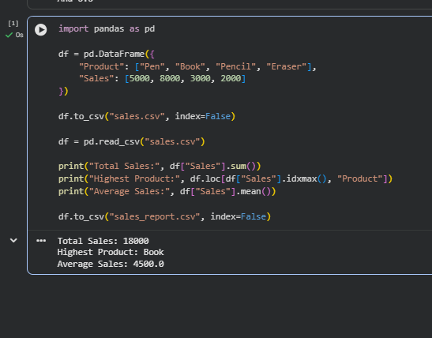

2. Weather Data Processing
Question - Write a Python program to process weather data from weather.csv.
Aim:
To read weather data, find the highest and lowest temperatures, calculate average rainfall, and display days with rainfall greater than 100 mm.
Code:
import pandas as pd

data = {
"Day": ["Mon", "Tue", "Wed", "Thu", "Fri"],
"Temperature": [30, 35, 28, 40, 32],
"Rainfall": [50, 120, 80, 150, 60]
}

df = pd.DataFrame(data)
df.to_csv("weather.csv", index=False)

data = pd.read_csv("weather.csv")

print("Highest Temperature:", data["Temperature"].max())
print("Lowest Temperature:", data["Temperature"].min())
print("Average Rainfall:", data["Rainfall"].mean())

print("\nRainfall Greater Than 100 mm")
print(data[data["Rainfall"] > 100])
OUTPUT:
